**IMS Engineering College, Ghaziabad**



Mini Project

**Subject Name: Mini project**

**Subject Code: KCS-554**

COURSE: B.Tech.

SEMESTER: 5th

**by**

Prakhar Tiwari (2001430100155)

**Department of Computer Science and Engineering**

**IMS ENGINEERING COLLEGE**

**NH-09, Adhyatmik Nagar, Ghaziabad-201015**

**(2022-23)**

**Vision and Mission of the Institute and Department**

**Vision of the Institute**

“To make IMSEC an Institution of Excellence for empowering students through technical education coupled with incorporating values and developing engineering acumen for innovations and leadership skills for the betterment of society.”

**Mission of the Institute**

* To promote academic excellence by continuous learning in core and emerging Engineering areas using innovative teaching and learning methodologies.
* To inculcate values and ethics among the learners.
* To promote industry interactions and produce young entrepreneurs.
* To create a conducive learning and research environment for life-long learning to develop the students as technology leaders and entrepreneurs for addressing societal needs.

**Vision of the Department**

To provide globally competent professionals in the field of Computer Science & Engineering embedded with sound technical knowledge, aptitude for research and innovation with ethical values to cater to the industrial & societal needs.

**Mission of the Department**

M1: To provide quality undergraduate education in both the theoretical & applied foundations of Computer Science Engineering.

M2: Conduct research to advance the state of the art in Computer Science & Engineering and integrate the research results as innovations.

M3: To inculcate team building skills and promote life-long learning with high societal and ethical values**.**

**Program Outcomes (POs)**

|  |  |
| --- | --- |
| **S. No.** | **Program Outcomes / Program Specific Outcomes** |
| **PO1.** | **Engineering knowledge**: Apply the knowledge of mathematics, science, engineering fundamentals, and an engineering specialization to the solution of complex engineering problems. |
| **PO2.** | **Problem analysis:** Identify, formulate, review research literature, and analyze complex engineering problems reaching substantiated conclusions using first principles of mathematics, natural sciences, and engineering sciences. |
| **PO3.** | **Design/development of solutions:** Design solutions for complex engineering problems and design system components or processes that meet the specified needs with appropriate consideration for the public health and safety, and the cultural, societal, and environmental considerations. |
| **PO4.** | **Conduct investigations of complex problems:** Use research-based knowledge and research methods including design of experiments, analysis and interpretation of data, and synthesis of the information to provide valid conclusions. |
| **PO5.** | **Modern tool usage:** Create, select, and apply appropriate techniques, resources, and modern engineering and IT tools including prediction and modelling to complex engineering activities with an understanding of the limitations. |
| **PO6.** | **The engineer and society:** apply reasoning informed by the contextual knowledge to assess societal, health, safety, legal and cultural issues and the consequent responsibilities relevant to the professional engineering practice. |
| **PO7.** | **Environment and sustainability:** Understand the impact of the professional engineering solutions in societal and environmental contexts, and demonstrate the knowledge of, and need for sustainable development. |
| **PO8.** | **Ethics:** Apply ethical principles and commit to professional ethics and responsibilities and norms of the engineering practice. |
| **PO9.** | **Individual and team work**: Function effectively as an individual, and as a member or leader in diverse teams, and in multidisciplinary settings. |
| **PO10.** | **Communication:** Communicate effectively on complex engineering activities with the engineering community and with society at large, such as, being able to comprehend and write effective reports and design documentation, make effective presentations, and give and receive clear instructions. |
| **PO11.** | **Project management and finance:** Demonstrate knowledge and understanding of the engineering and management principles and apply these to one’s own work, as a member and leader in a team, to manage projects and in multidisciplinary environments. |
| **PO12.** | **Life-long learning:** Recognize the need for, and have the preparation and ability to engage in independent and life-long learning in the broadest context of technological change. |

**Program Specific Outcomes (PSOs)**

PSO1: To apply standard software engineering practices & strategies in real-time software project development

PSO2: To apply latest programming languages in creating innovative career opportunities.

**Program Educational Objectives (PEOs)**

Graduate Will:

PEO1: Possess knowledge to enable continued professional development.

PEO2: Engage in life-long learning to foster personal & organization growth.

PEO3: Work productively as successful professionals in diverse career paths.

PEO4: Effectively communicate ideas to promote collaboration in accordance with societal standards & ethical practices.

**Course Outcomes**

|  |  |  |
| --- | --- | --- |
| **CO. No.** | **DESCRIPTION** | **COGNITIVE LEVEL (BLOOMS TAXONOMY)** |
| **CO1(C310.1)** | Developing a technical artifact requiring new technical skills and effectively utilizing a new software tool to complete a task | **K4,K5** |
| **CO2(C310.2)** | Writing requirements documentation, Selecting appropriate technologies, identifying and creating appropriate test cases for systems. | **K5,K6** |
| **CO3(C310.3)** | Demonstrating understanding of professional customs & practices and working with professional standards. | **K4,K5** |
| **CO4(C310.4)** | Improving problem-solving, critical thinking skills and report writing. | **K4,K5** |
| **CO5(C310.5)** | Learning professional skills like exercising leadership, behaving professionally, behaving ethically, listening effectively, participating as a member of a team, developing appropriate workplace attitudes | **K2,K4** |

**CO-PO-PSO Mapping**

|  |  |  |  |  |  |  |  |  |  |  |  |  |  |  |
| --- | --- | --- | --- | --- | --- | --- | --- | --- | --- | --- | --- | --- | --- | --- |
|  | **PO1** | **PO2** | **PO3** | **PO4** | **PO5** | **PO6** | **PO7** | **PO8** | **PO9** | **PO 10** | **PO 11** | **PO 12** | **PSO1** | **PSO2** |
| **C310.1** | 3 | 3 | 3 | 3 | 3 | 2 | 1 | 2 | 2 | 2 | 2 | 3 | 3 | 3 |
| **C310.2** | 3 | 3 | 2 | 2 | 2 | 1 | 1 | 2 | 2 | 3 | 1 | 1 | 2 | 3 |
| **C310.3** | 1 | 1 | 1 | 1 | 1 | 3 | 2 | 3 | 2 | 2 | 2 | 2 | 2 | 1 |
| **C310.4** | 3 | 3 | 3 | 3 | 3 | 2 | 1 | 1 | 2 | 3 | 1 | 3 | 1 | 1 |
| **C310.5** | 1 | 1 | 1 | 1 | 1 | 2 | 2 | 3 | 3 | 3 | 3 | 1 | 1 | 1 |
| **C310** | **2.2** | **2.2** | **2** | **2** | **2** | **2** | **1.4** | **2.2** | **2.2** | **2.6** | **1.8** | **2** | **1.8** | **1.8** |

## DECLARATION

*I hereby declare that this submission is my own work and that, to the best of my knowledge and belief, it contains no material previously published or written by another person nor material which to a substantial extent has been accepted for the award of any other degree or diploma of the university or other institute of higher learning, except where due acknowledgment has been made in the text.*

### Signature*:*

**Name** *: Prakhar Tiwari*

**Roll No***: 2001430100155*

**Date** *:*

### Signature*:*

**Name** *: Pawan*

**Roll No***: 2001430100144*

**Date** *:*

### Signature*:*

**Name** *: Peeush Gupta*

**Roll No***: 2001430100145*

**Date** *:*

### Signature*:*

**Name** *: Naman Rajput*

**Roll No***: 2001430100133*

**Date** *:*

### Signature*:*

**Name** *: Piyush Singh*

**Roll No***: 2001430100147*

**Date** *:*

## CERTIFICATE

This is to certify that Mini Project/Internship Assessment Report entitled “Resume Builder App” which is submitted by Prakhar Tiwari in partial fulfillment of the requirement for the award of degree B. Tech. in Department of Computer Science and Engineering of Dr. APJ Abdul Kalam Technical University, Uttar Pradesh, Lucknow is a record of the candidate’s own work carried out by him/her under my supervision. The matter embodied in this report is original and has not been submitted for the award of any other degree.

**Supervisor : Mr. Basudeo Singh Roohani**

**Date :**

## ACKNOWLEDGEMENT

I would like to express my gratitude to Mr. Basudeo Singh Roohani supervisor for this project. I would like to thank her for her constant support, enthusiastic encouragement and useful critiques. I would like to thank our Director Dr. Vikram Baliand HOD of Computer Science and Engineering Dr. Sonali Mathur for providing me this opportunity.

## ABSTRACT

In today’s world we all know the importance of Resume in anyone’s life seeking for a job. There are many applications available on play store and web store but it is very difficult to find a suitable application.

We provide our project named “RESUME BUILDER APP” that provides a simple and sustainable solution for our problems to create a resume and to organize it on a template. In this app there are various templates which we can use to make our resume attractive.

As resume provides the first impression towards the selectors the resume should be attractive and well prepared.

Our application is unique from all the existing e-commerce application as it provides following features:

* This app will provide you a simple way to fill the details and select a good template as per our requirement.
* This app will also provide cross platform support so it is compatible on android, web, mac etc.

**TABLE OF CONTENTS**

**Contents Page No.**

1. Declaration ……………………………………………………………………… 6
2. Certificate ………………………………………………………………………. 7
3. Acknowledgement ………………………………………………………………. 8
4. Abstract ………………………………………………………………………….. 9
5. Introduction … …………………………………………………………………..10
6. Tools & Technologies Used ……………………………………………………...13
7. History & Features of the Technology Used …………………………………….15
8. Work done………………………………………………………………………..17
9. Conclusion…………………………………………………………………………20
10. References…………………………………………………………………………21

## INTRODUCTION

**What is Resume**

A resume (or “[CV](https://resumegenius.com/blog/cv-help/what-is-a-cv)” outside of the US) is a formal document that provides an overview of your professional qualifications, including your relevant work experience, skills, education, and notable accomplishments. Usually paired with a cover letter, a resume helps you demonstrate your abilities and convince employers you’re qualified and hireable.

**Purpose**

The purpose of a resume is to show employers you’re **qualified for a position** and convince them to offer you an interview.

If your resume quickly makes your ability to handle the work clear to hiring managers, you’ll catch their attention and get more interviews.

**Types**

There are four main types of resumes:

1. Chronological resume
2. Functional resume
3. Targeted resume
4. Combination resume

**About app**

You can use our app to create your resume anytime and anywhere. Our app provides you complete flexibility of time, place and device. Our app is compatible with android, ios and web application. Our app provide you multiple templates that are well organized, eye cache and in trend nowadays. You can select any of the template according to your liking and get a Resume in that format(template).

**Future Scope**

We have decided that in coming future we will add a recommendation system in our app which will help people to get recommendations about their best suitable job as per their resume.

Also we will keep on adding new templates in our app for keeping the people using our app up to dated.

**Tools & Technologies Used**

* **ReactJS**

React makes it painless to create interactive UIs. Design simple views for each state in your application, and React will efficiently update and render just the right components when your data changes. Declarative views make your code more predictable and easier to debug. It is Component-Based, build encapsulated components that manage their own state, then compose them to make complex UIs. Since component logic is written in JavaScript instead of templates, you can easily pass rich data through your app and keep state out of the DOM. We don’t make assumptions about the rest of your technology stack, so you can develop new features in React without rewriting existing code. React can also render on the server using Node and power mobile apps using React Native.

* **React Native**

React Native is an open-source UI software framework. It is used to develop applications for Android, Android TV, iOS, macOS, Vos, Web, Windows and UWP by enabling developers to use the React framework along with native platform capabilities. It is also being used to develop virtual reality applications at Oculus.

React Native Expo

React Native Expo is a bundle of tools created around React Native to help you start an app very fast. It provides you with a list of tools that simplify the creation and testing of React Native app. It equips you with the components of the user interface and services. If you are given a project that needs rapid development, and you have picked React Native to build the cross-platform app, Expo is the best fit for you. With Expo, you can build and deploy React Native apps for both iOS and Android with ease.

* **React native navigation**

Mobile apps are made up of multiple screens. When building mobile apps, of primary concern is how to handle a user’s navigation through the app — e.g., the presentation of the screens and the transitions between them. React Navigation is one of the most well-known navigation libraries available for React.

* **Android Studio**

Android Studio is the official integrated development environment (IDE) for Google's Android operating system, built on JetBrains' IntelliJ IDEA software and designed specifically for Android development. It is available for download on Windows, macOS and Linux based operating systems. It is a replacement for the Eclipse Android Development Tools (E-ADT) as the primary IDE for native Android application development.

Android Studio provides a unified environment where you can build apps for Android phones, tablets, Android Wear, Android TV, and Android Auto. Structured code modules allow you to divide your project into units of functionality that you can independently build, test, and debug.

* **Expo Print**

It provides an API for iOS (AirPrint) and Android printing functionality.

* **Expo Share**

It allows you to share files directly with other compatible applications.

**History & Features of the Technology Used**

* **React JS**

React was created by Jordan Walke, a software engineer at Facebook, who released an early prototype of React called "FaxJS". He was influenced by XHP, an HTML component library for PHP. It was first deployed on Facebook's News Feed in 2011 and later on Instagram in 2012.It was open-sourced at JSConf US in May 2013.

React is a JavaScript library developed by Facebook which, among other things, was used to build Instagram.com. Its aim is to allow developers to easily create fast user interfaces for websites and applications alike. The main concept of React. js is virtual DOM

**ReactJS Features:**

⦁ JSX - JavaScript Syntax Extension. JSX is a preferable choice for many web developers. ...

⦁ Unidirectional Data Flow and Flux. React. ...

⦁ Virtual Document Object Model (VDOM) React contains a lightweight representation of real DOM in the memory called Virtual DOM. ...

⦁ Extensions. ...

⦁ Debugging.

* **React Native**

React Native is one of the most popular mobile app development frameworks designed and developed by Facebook. React Native was first developed in 2013 as an internal Facebook project, and then released to the public in 2015.

**React Native Features :**

⦁ Write Once Use Anywhere

⦁ UI Focused

⦁ Programming Language

⦁ Strong Community

⦁ Tried & Tested

⦁ Support For 3rd Party

⦁ Development time

* **React-Native-Expo**

Expo was founded in October 2013 by Charlie Cheever and James Ide to improve mobile software and its development. The company started with research and prototypes of using JavaScript to program native mobile applications more easily, an uncommon technique at the time.

The first version of the Expo development client was released for iPhone in May 2015 soon after the release of React Native earlier that year. The Expo development client for Android followed in December 2015 after the later release of React Native Android.

**React Native Expo Features:**

⦁ Fastest way to build React Native Apps.

⦁ You don't need to know Native Mobile coding.

⦁ No XCode, No Android Studio.

⦁ Publish Over the Air (OTA) Updates Instantly.

⦁ In-built access to Native APIs.

⦁ It is FREE and Open Source.

* **Android Studio**

Android Studio was announced on May 16, 2013, at the Google I/O conference. It was in early access preview stage starting from version 0.1 in May 2013, then entered beta stage starting from version 0.8 which was released in June 2014.The first stable build was released in December 2014, starting from version 1.0.

**Android Studio Features:**

⦁ Gradle-based build support

⦁ Android-specific refactoring and quick fixes

⦁ Lint tools to catch performance, usability, version compatibility and other problems

⦁ ProGuard integration and app-signing capabilities

⦁ Template-based wizards to create common Android designs and components

⦁ A rich layout editor that allows users to drag-and-drop UI components, option to preview layouts on multiple screen configurations

⦁ Support for building Android Wear apps

⦁ Built-in support for Google Cloud Platform, enabling integration with Firebase Cloud Messaging (Earlier 'Google Cloud Messaging') and Google App Engine

⦁ Android Virtual Device (Emulator) to run and debug apps in the Android studio.

* **Expo Print**

It is a module of Javascript which provide you the functionality of printing a document in a specific format.

**Features:**

* Platform Compatibility
  1. Android Device
  2. Android Emulator
  3. iOS Device
  4. iOS Simulator
  5. Web
* **Expo Share**
* expo-sharing for web is built on top of the Web Share API, which still has [very limited browser support](https://caniuse.com/#feat=web-share). Be sure to check that the API can be used before calling it by using Sharing.isAvailableAsync().
* **HTTPS required on web**: The Web Share API is only available on web when the page is served over https. Run your app with npx expo start --https to enable it.

**Features:**

Platform Compatibility:

* + 1. Android Studio
    2. Android Emulator
    3. iOS Device
    4. iOS Simulator
    5. Web

H

**WORK DONE**

**Flow Chart**

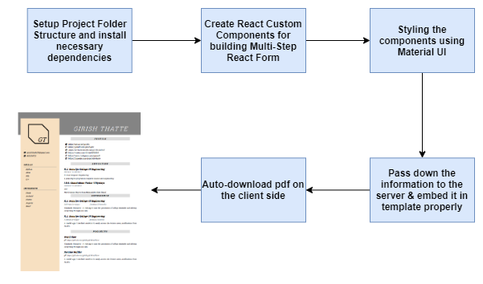

**Application Design**

* Splash Screen
* App logo
* Home Page
  + - App Icon
    - Slogan
    - Start Button
* Information Page
  + - Input field of personal information

1. Name
2. Education
3. Experience
4. Skills
5. Summary
6. Achievements
   * + Click-Resume-Button

* Template page
  + - Multiple Template/Format
    - Select template
* Preview page
  + - Resume generated
    - Download button
    - Share button
* Download Button

=>download the resume in pdf format

**Working**

When you open the app you will see a splash screen. You will reach directly to Home page. After clicking Start button, you will be navigated to Input page. There the user will provide his/her personal details such as Name, Qualification, Achievements and etc. After that you will be navigated to template selection page where you can select any of the given template as per your likings and interest. After that you will get download button where you can save your resume in your storage in pdf form.

**SCREENS**

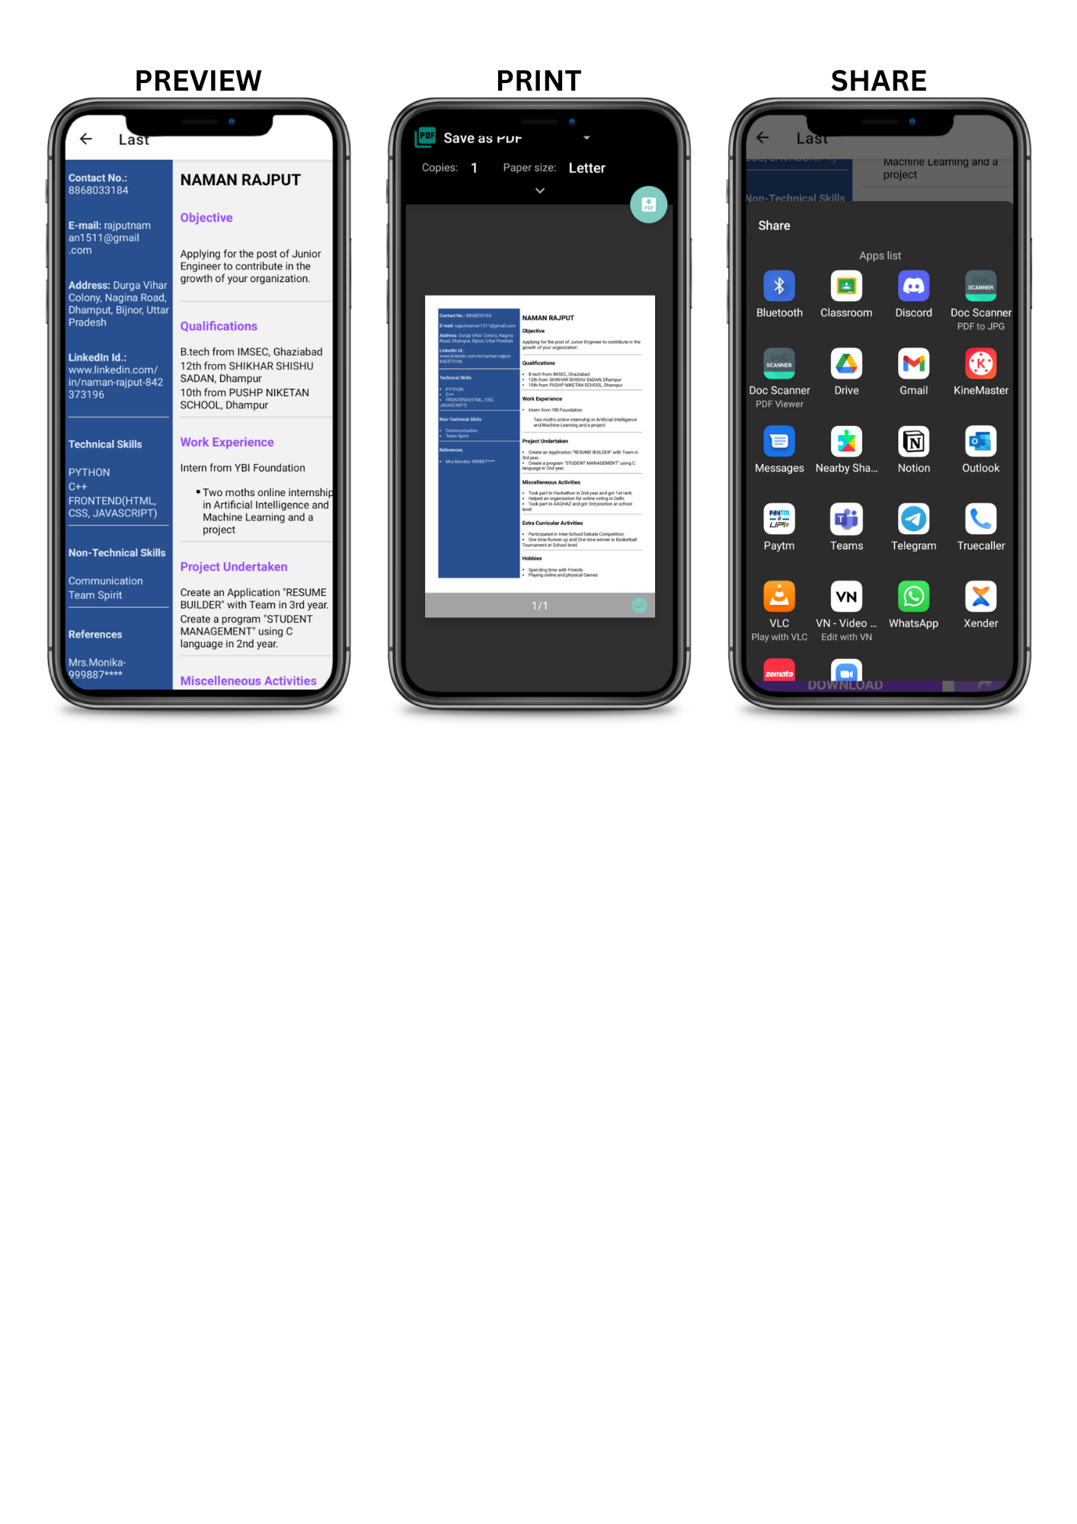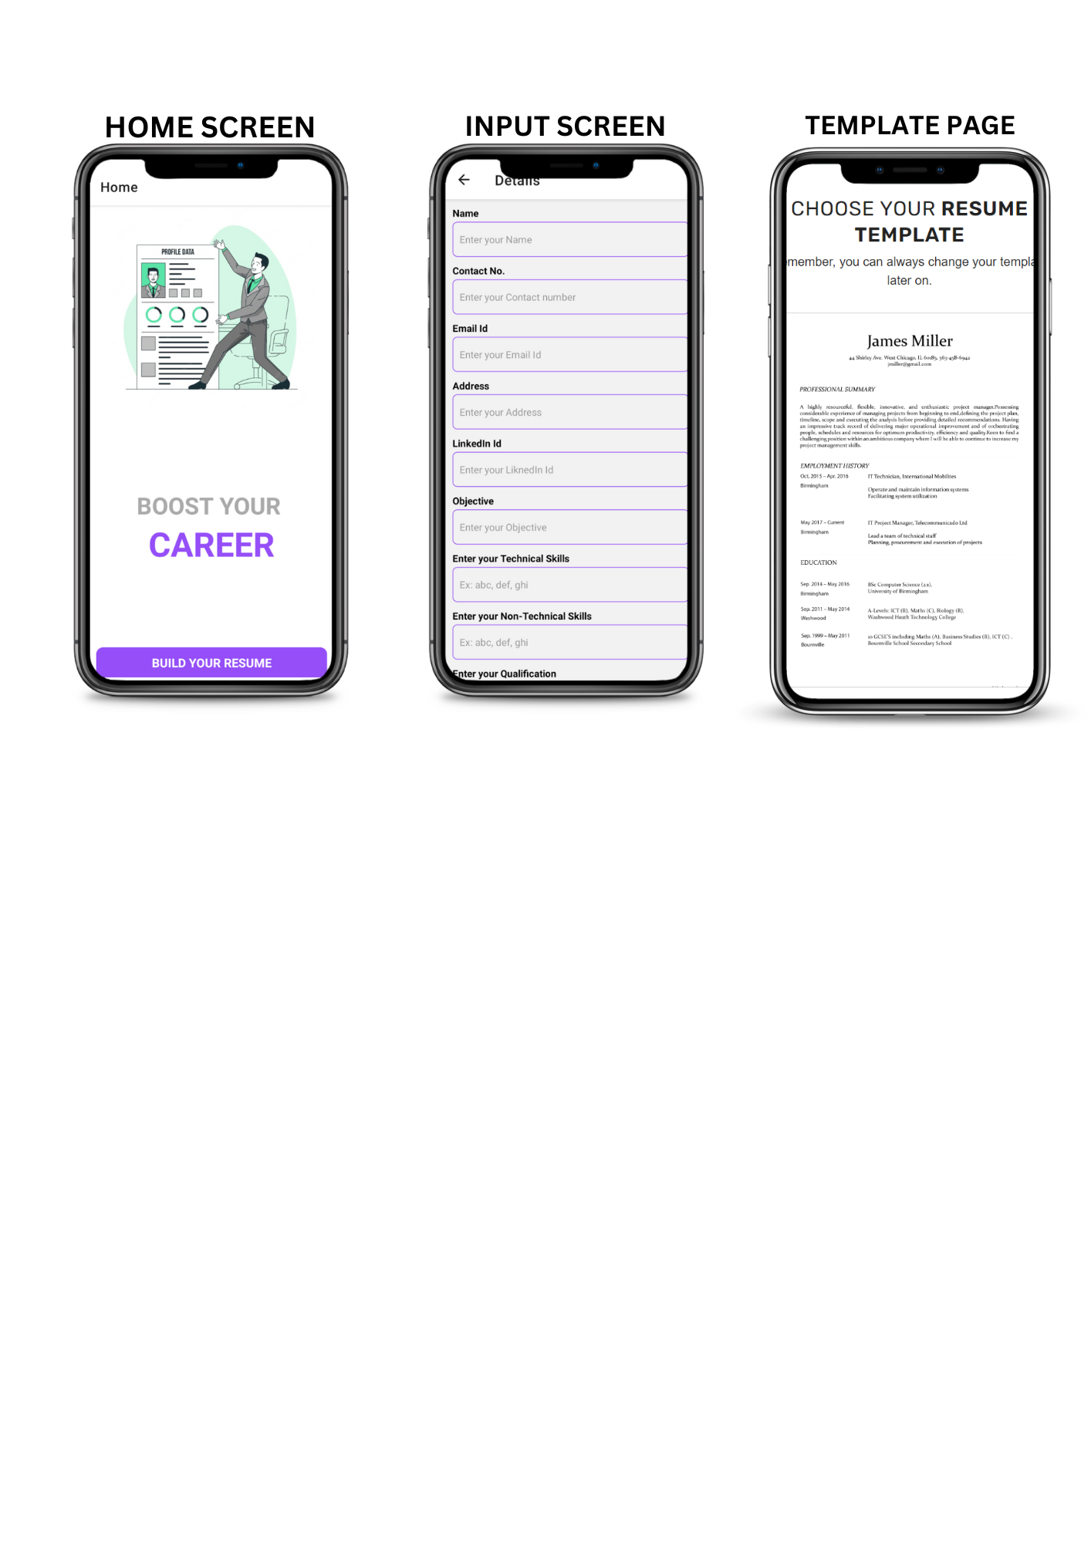fjkldkdfldjjklsldj

**CONCLUSION**

Your resume is not a ‘tell all’ summary of your skills, strengths and accomplishments. Yes, you want to showcase your talents and how they positively impacted organizations in which you worked. But, your resume should leave unanswered questions, to inspire the reader to want to meet you, to learn more about you and what you have done. If you answer ALL the questions a hiring manager or recruiter may have, you lessen the possibility of an in-person interview.

You can easily trust our app which is user friendly and feature rich providing from multiple templates to cross platform support at zero cost.

C

**vv REFERENCE**

* [**https://docs.expo.dev/**](https://docs.expo.dev/)
* [**https://docs.nativebase.io/**](https://docs.nativebase.io/)
* [**https://www.google.com/**](https://www.google.com/)
* [**https://www.youtube.com/**](https://www.youtube.com/)
* [**https://reactnavigation.org/docs/**](https://reactnavigation.org/docs/)
* [**https://docs.expo.dev/versions/latest/sdk/sharing/**](https://docs.expo.dev/versions/latest/sdk/sharing/)
* [**https://docs.expo.dev/versions/latest/sdk/print/**](https://docs.expo.dev/versions/latest/sdk/print/)
* [**https://react.org/docs/**](https://react.org/docs/)
* [**https://nodejs.org/docs/**](https://nodejs.org/docs/)
* [**https://developer.android.com/docs**](https://developer.android.com/docs)

**IMS Engineering College, Ghaziabad**

**PROFORMA OF MINI-PROJECT PROPOSAL**

**Name of the Mini Project : RESUME BUILDER APP** **Date :**………………

|  |  |  |  |
| --- | --- | --- | --- |
| **S. No** | **Roll number** | **Student Name** | **Signature** |
| 1. | 2001430100155 | PRAKHAR TIWARI |  |
| 2. | 2001430100144 | PAWAN |  |
| 3. | 2001430100145 | PEEUSH GUPTA |  |
| 4. | 2001430100133 | NAMAN RAJPUT |  |
| 5. | 2001430100147 | PIYUSH SINGH |  |

**AIM of Mini Project: CREATING A “RESUME BUILDER APP” USING REACT NATIVE**

**Methodology Used:**

**Technology Used:**

**Supervisor Name: MR. BASUDEO SINGH ROOHANI**

Signature of the Supervisor

Date: …………………